

Online Exam

|  |  |
| --- | --- |
| Full Course Code | MAM2022 AM01 AUT21 |
| Course Title | Applied Statistics |
| Faculty | Kostis Christodoulou |
| Date of Exam | 24 September 2021 |

|  |  |  |  |  |  |  |  |
| --- | --- | --- | --- | --- | --- | --- | --- |
| **STUDENT TO COMPLETE BEFORE STARTING EXAM** | | | | | | | |
| **LBS Number** | 3 | 7 | 7 | 5 | 1 | 8 | 3 |
| **Stream (if applicable)** |  |  |  |  |  |  |  |

|  |
| --- |
| By downloading this exam paper, you have:   * Read and understood the **Online Exams Policy** and **Exam Instructions**. * Agreed to complete the exam **individually** without discussion or collaboration with others. * Agreed to upload and submit the file(s) on Canvas before the final 15 minutes of the exam, and only use the **final 15 minutes** to resolve any **technical issues.** * Understood that submissions received **after** the deadline will be subject to a late submission penalty as per section 5 of the Online Exams Policy. |

**Question 1 (25 points)**

You are presented with data on ***hotel_bookings***, with data on two hotels, a Resort and a City Hotel. Here is what the dataframe looks like

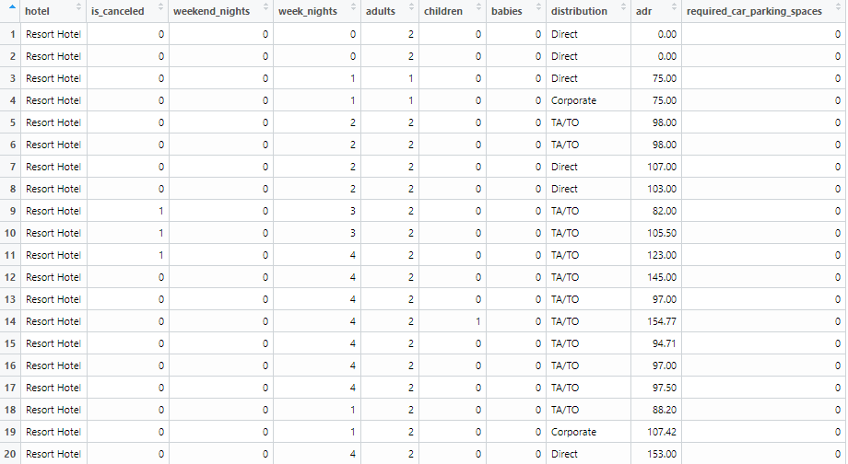

The variables types are shown below and the two that are not obvious are

***is_canceled***: 0 if the booking was not cancelled, 1 if it was cancelled

***adr***: Average Daily Rate, in Euros

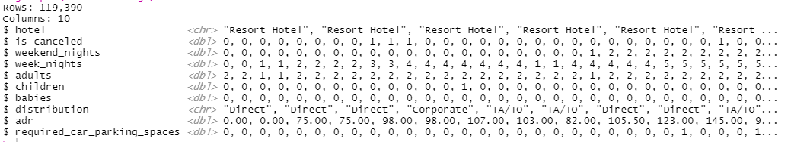

Use dplyr commands that will produce the following. You don’t need to calculate the output table, just write the code that would produce it.

**Part a (5 pts)** Which distribution channel (***distribution***) generates the greatest number of bookings in terms of volume? Calculate both counts and percentages and sort your table in descending order

hotel_bookings %>%

*# filter(is_canceled!=1) %>%* *# I think canceled records still should be counted as volume*

group_by(distribution) %>%

summarise(count = n(), *# My understanding of volume is the number of entries rather than the number of rooms booked*

percentage = count/nrow(hotel_bookings)) %>% *# or mutate(percentage = count/n()) to avoid write dataset as a parameter*

arrange(-count) *# sort in descending order*

**Part b (5 pts)** Which distribution channel (***distribution***) generates the greatest revenue? Calculate both the total revenue each distribution channel generated and its percentage contribution to the total revenue. Use the average daily revenue (***adr***) and apply that to both week_nights and weekend_nights.

hotel_bookings %>%

filter(is_canceled!=1) %>% *# no revenue for canceled bookins this time.*

mutate(revenue = ((week_nights+ weekend_nights) * adr)) %>% *# calculate revenue per booking*

group_by(distribution) %>%

summarise(channel_revenue = sum(revenue)) %>% *# sum revenue by channel*

mutate(contribution = channel_revenue / sum(channel_revenue)) %>% *# calculate percentage contribution to total revenue*

arrange(-channel_revenue) *# sort by revenue in desc order*

**Part c (5 pts)** For those customers who did stay, what proportion had a booking that involved kids (either *children* or *babies*).

hotel_bookings %>%

filter(is_canceled!=1) %>% *# for those who did stay*

mutate(kid_involved = if(children+babies >0, 1, 0)) %>% *# add an indicator column*

summarise(prop_with_kid = sum(kid_involved)/n()) *# calculate proportion*

**Part d (10 pts)** Using tidyverse packages and functions, how you would you create the following plot that looks at cancellation status (***is_cancelled***) by hotel type?

hotel_bookings %>%

group_by(hotel) %>%

summarise(cancel_rate = round(100 * sum(is_cancelled)/n(),1)) %>% *# calculate cancel rate (%)*

mutate(not_cancel_rate = round(100 – canel_rate,1)) %>% *# calculate not cancel rate*

pivot_longer(cols = c("cancel_rate ":" not_cancel_rate"), *# or cols=2:3*

names_to = "status",

values_to="rate") %>%

mutate(status = if_else(status == "cancel_rate", "Canceled", "Not Canceled"))

ggplot(aes(x=fct_relevel(hotel, levels=c("City Hotel","Resort Hotel")), y=rate, fill=status)) +

geom_bar(position="dodge") + *# make bars together*

geom_text(aes(label=rate, vjust=1)+ *# add data label to the bars*

labs(

title = "Cancellation Status (%) by Hotel Type",

x = "Hotel Type",

y= "",

fill = "Cancellation Status"

) +

Scale_fill_manual("Cancellation Status",

breaks = c("Not Canceled","Canceled"),

values = c("grey ","red")) *# fill the bars with corresponding color*

theme_bw() +

NULL

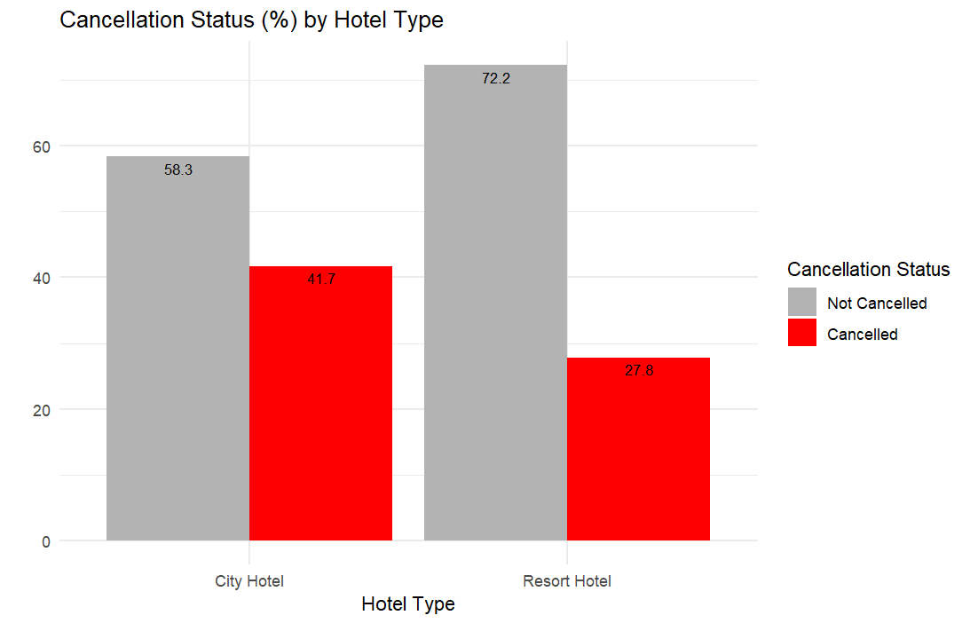

**Question 2 (20 points)**

A bank wants to study whether there is any difference in credit card balances between those who own their house (***own_yes***) and those who don’t (***own_no***). They collected a sample of customers and the summary statistics are given below:

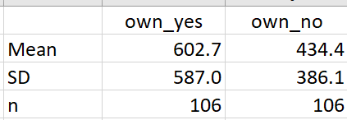

**Part a (3 points)**: Please state what is the population, the sample, the parameter you want to infer, and the available sample statistic

The population is the set of (credit card balances of) all the customers/people.

The sample is the set of (credit card balances of) the 212 customers (106 own their house and 106 do not) in the survey.

The parameter I want to infer is the difference between the population mean of credit card balances of two types of people.

The available sample statistic is $\hat{μ_{yes}}- \hat{μ_{no}}=602.7-434.4=168$

**Part b (7 points)** Construct two 95% confidence intervals; one for the average card balance for those who own their house (own_yes) and one for those who don’t (own_no). Do you have to make any assumptions?

$$\hat{σ_{yes}}=\frac{587}{\sqrt{106}}=57$$

$$\hat{σ_{no}}=\frac{386.1}{\sqrt{106}}=37.5$$

Confidence interval $μ_{yes}$ is

$\left[602.7-1.96×57, 602.7+1.96×57\right]=\left[491, 714\right]$

Confidence interval $μ_{no}$ is

$\left[386.1-1.96×37.5, 386.1+1.96×37.5\right]=\left[313, 460\right]$

The sample is large enough for CLT to apply (n>>30), so I can suppose the sample mean follows a normal distribution. Assumptions are not needed. (H0 below will be rejected.)

**Part c (10 points)** Based on this sample, test whether or not the mean difference of credit card balances for those customers who own their house is the same as those who don’t. Use a 5% significance level. Conduct a hypothesis testing, state the null and the alternative, calculate a t-statistic for the difference, and finally state what you decide/infer.

$$H_{0}: \hat{μ_{yes}}- \hat{μ_{no}}=0$$

$$H_{1}: \hat{μ_{yes}}- \hat{μ_{no}}≠0$$

The first is null hypothesis and the other is alternative.

$$\hat{σ_{diff}}=\sqrt{\frac{{587}^{2}}{106}+\frac{{386.1}^{2}}{106}}=68.2$$

$$t stat=\frac{\hat{μ_{yes}}- \hat{μ_{no}}}{\hat{σ_{diff}}}=\frac{168}{68.2}=2.46>2$$

I can reject the null hypothesis with 95% confidence level. My final statement is the difference between the population means of credit card balances for those customers who own their house and those who don’t is statistically significant different from 0. The difference exists.

**Question 3 (25 points)**

The following data is about median house value (***house_value***, in thousands of $) for 506 census districts in the greater Boston are. The variables are as follows

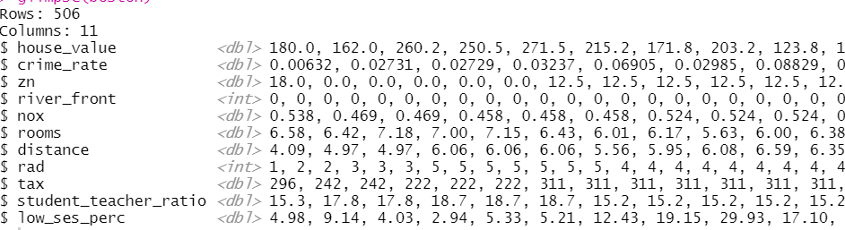

**crime_rate**: per capita crime rate by town.

**zn**: proportion of residential land zoned for lots over 25,000 sq.ft.

**river**_front: Charles River dummy variable (= 1 if tract bounds river; 0 otherwise).

**nox**: nitrogen oxides concentration (parts per 10 million).

**rooms**: average number of rooms per dwelling.

**age**: proportion of owner-occupied units built prior to 1940.

**distance**: weighted mean of distances to five Boston employment centres.

**rad**: index of accessibility to radial highways.

**tax**: full-value property-tax rate per $10,000.

**student_teacher_ratio:** Student-teacher ratio by town.

**low_ses_perc**: lower status of the population (percent).

**Part a (5 pts)**

The following output summarises the data set

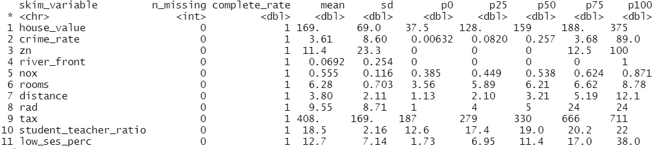

… and as usual the first model we run is

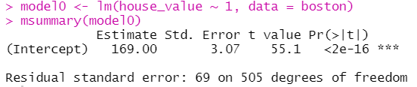

Without looking at a graph, how would you determine whether the distribution of ***house***_***value*** is symmetric or skewed? What is a 95% confidence interval for the average of ***house_value***?

The house_value variable is right skewed because the mean is larger than p50 (or median).

The 95% confidence interval for the average of house_value is

$$[169 - 1.96 * \frac{69}{\sqrt{506}} , 169 + 1.96 *\frac{69}{\sqrt{506}} ] = [163, 175]$$

**Part b (5 pts)**

You use ***crime_rate***, ***rooms***, and ***low_ses_perc*** to fit your first model to explain ***house_value***. Below is the scatterplot matrix and the regression output.

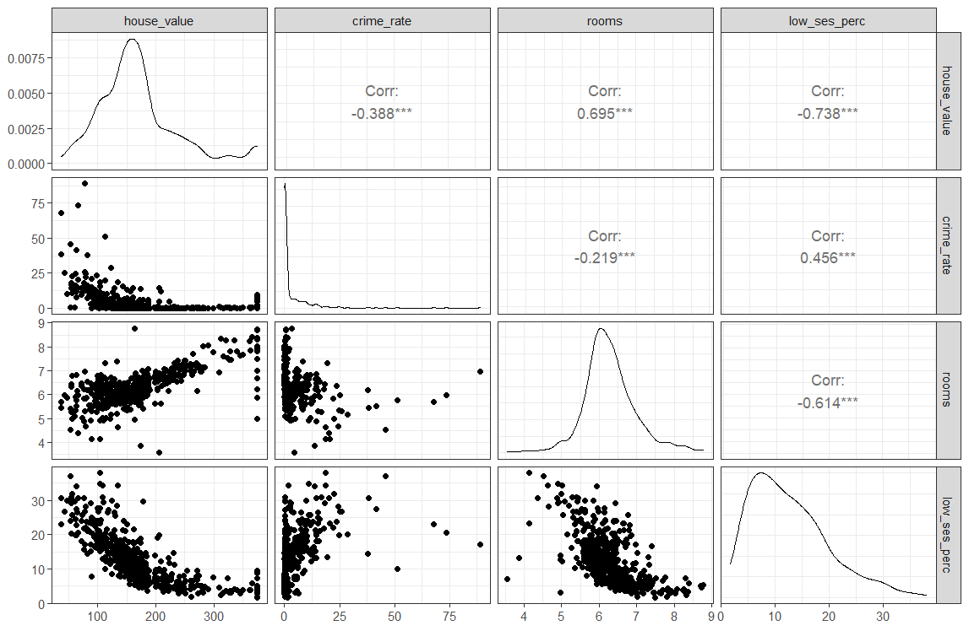

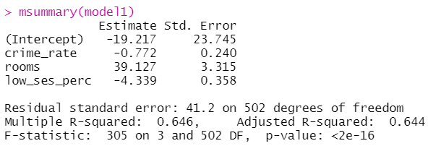

Write out the equation of the linear model and escribe the results obtained (2pt).

Are the slopes you estimated significant? (2pts)

What proportion of the variability in *house_value* does your model explain? (1pts)

Equation:

house_value = -19.217 - 0.772 * crime_rate + 39.127 * rooms - 4.339 * low_ses_perc

std: 23.745, 0.240, 3.315, 0.358

t-value: -0.819, -3.22, 11.8, 12.1

Pr(>|t|): 0.413, 0.00136, approx. 0, approx. 0

All the variables **except for intercept** are significant with 95% confidence level.

Based on R-squared, 64.6% of the variability is explained. (Adjusted R-squared adds penalty on number of independent variables.)

**Part c (5 pts)**

Using model 1, please construct a 95% prediction interval for ***house_value,*** given that crime_rate = 4, rooms = 6, and low_ses_perc = 15.

Pointwise prediction = -19.217 - 0.772 * 4 + 39.127 * 6 - 4.339 * 15 = 147

Std of prediction = 41.2

95% confidence interval for the house = [147 - 1.96 * 41.2, 147 + 1.96 * 41.2] = [66.2, 228]

(degrees of freedom is large enough to use 1.96)

**Part d (5 pts)**

The following are the diagnostic plots for model 1. What do you see? How could you improve model 1?

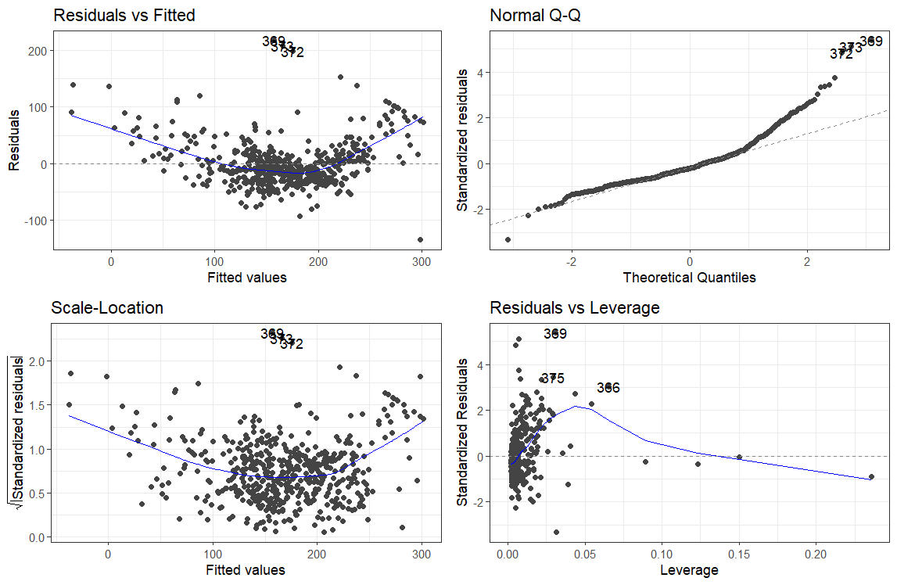

From the plots I can see that the residuals are larger at both ends (when fitted value is low or high). That indicates the relationship may be not linear. Adding quadratic variables may help.

The residuals are still not normally distributed, so there is much space to improve the models. We can also try to add more variables from the dataset to explain the house_value.

Adding multipliers into the equation may also help to improve the model.

**Part e (5 pts)** You now decide to fit a model with all predictors; the scatterplot matrix and associated regression output is given below

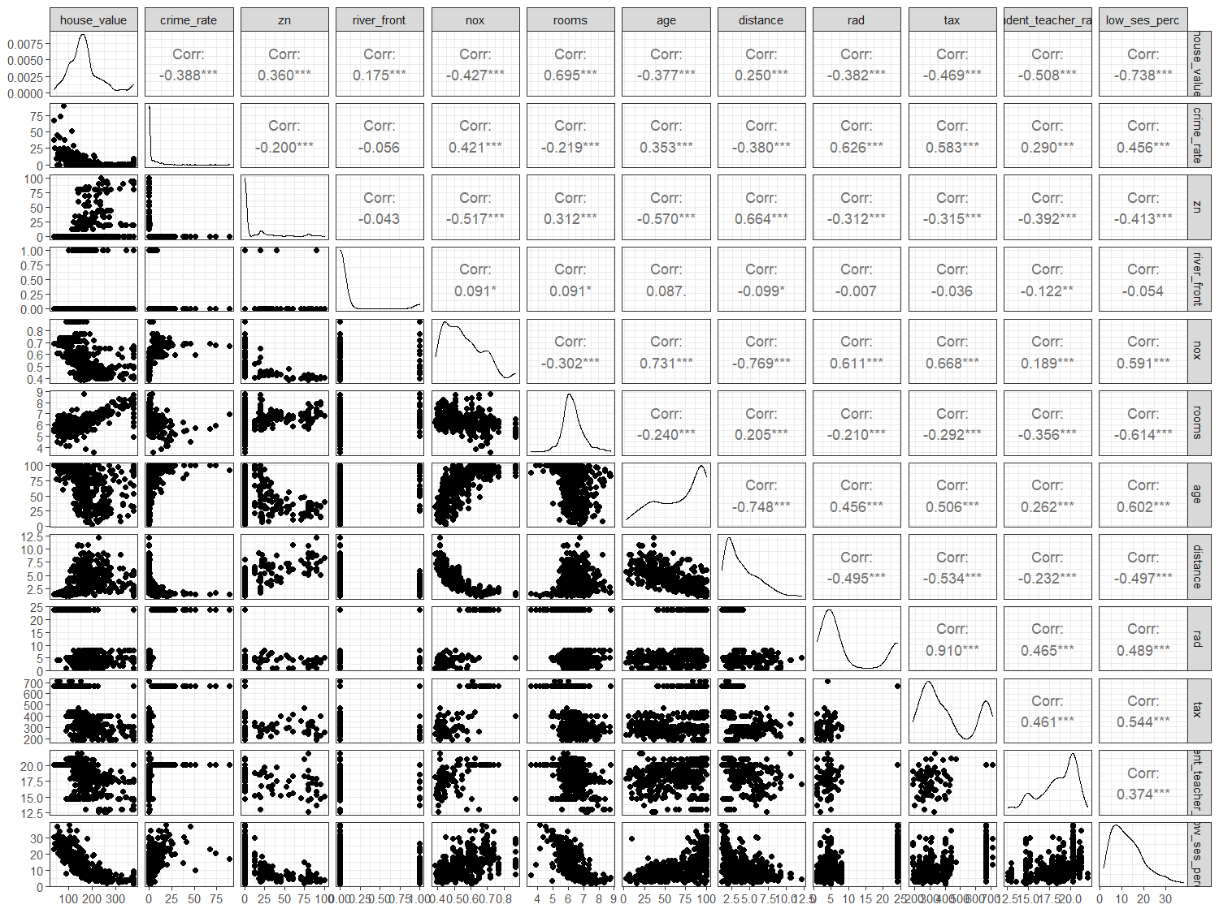

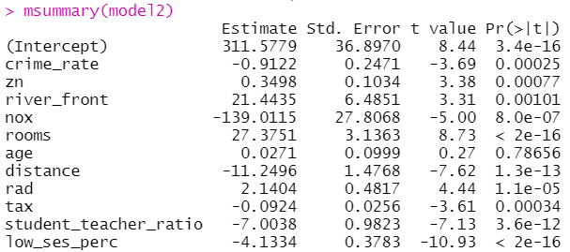

Explain the effect of ***river_front.*** Is it significant? [2 pts]

Is there anything that would make you worried about model 2? [3 pts]

The statistics for river_front shows that if a house is in front of a river, the price of it will increase by 21.4435 on average. T-stat is 0.00101, which is smaller than 0.01, so it is significant with 99% confidence level.

The variable age is not significant. We may remove the variable and compare the adjusted R-squared.

Adding too many variables may introduce overfitting problem into the model. We may split the data into training and testing set to see if the model performs well on both data sets.